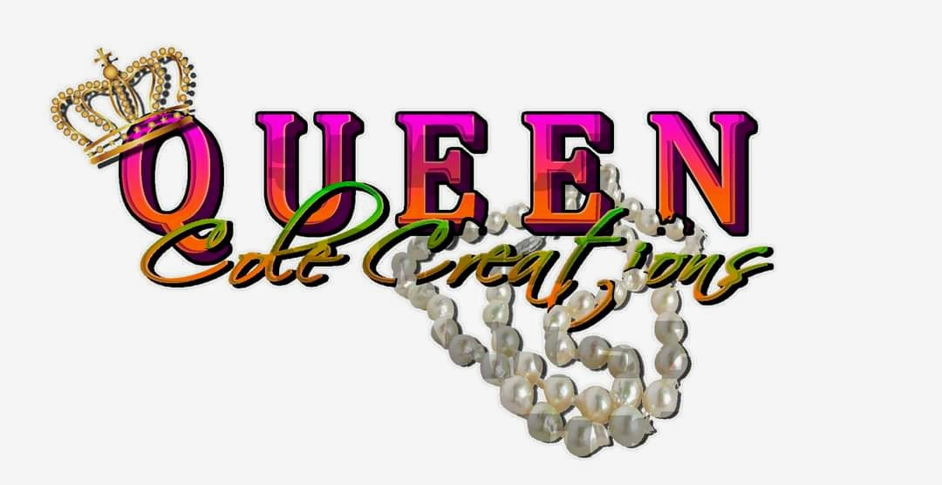

EXCHANGE POLICY

Queen Cole Creations is pleased to offer exchanges within 14 days of the purchase date. To be eligible for a return, items must be in their original condition, unwashed, unworn, unaltered and free from any odor, with all original tags still attached. Please note that all SALE items are considered FINAL SALE and are not eligible.

I kindly remind you that shipping and handling charges are non-refundable

and you are responsible for the return postage costs. I sincerely appreciate your business and thank you for choosing Queen Cole Creations for your handmade jewelry and accessories.